1.Create one VPC, with 1 public subnet and 1 private subnet:-

- Objective:-

- The objective of this task was to create a Virtual Private Cloud (VPC) and divide it into two separate network segments: a Public Subnet and a Private Subnet. This setup provides a basic AWS network architecture that allows resources to be organized based on their accessibility requirements.

- ## Step 1: Creating the VPC

- The first step was to create a VPC named **My-VPC** with the IPv4 CIDR block **10.0.0.0/16**. The VPC acts as an isolated network environment within AWS, providing a private space to deploy cloud resources securely.

- ## Step 2: Creating the Public Subnet

- Next, a subnet named **Public-Subnet** was created inside the VPC with the CIDR block **10.0.1.0/24**. This subnet was designed to host resources that may require direct access to external networks. Auto-assign Public IP was enabled so that instances launched in this subnet can automatically receive public IP addresses.

- ## Step 3: Creating the Private Subnet

- A second subnet named **Private-Subnet** was created within the same VPC using the CIDR block **10.0.2.0/24**. This subnet is intended for internal resources that should remain isolated from direct public access, providing an additional layer of security.

- ## Outcome

- Upon completion of the task, a VPC containing two subnets was successfully created:

  - VPC: 10.0.0.0/16
  - Public Subnet: 10.0.1.0/24
  - Private Subnet: 10.0.2.0/24

- This architecture forms the foundation for deploying secure and scalable AWS resources by separating publicly accessible components from internal workloads.

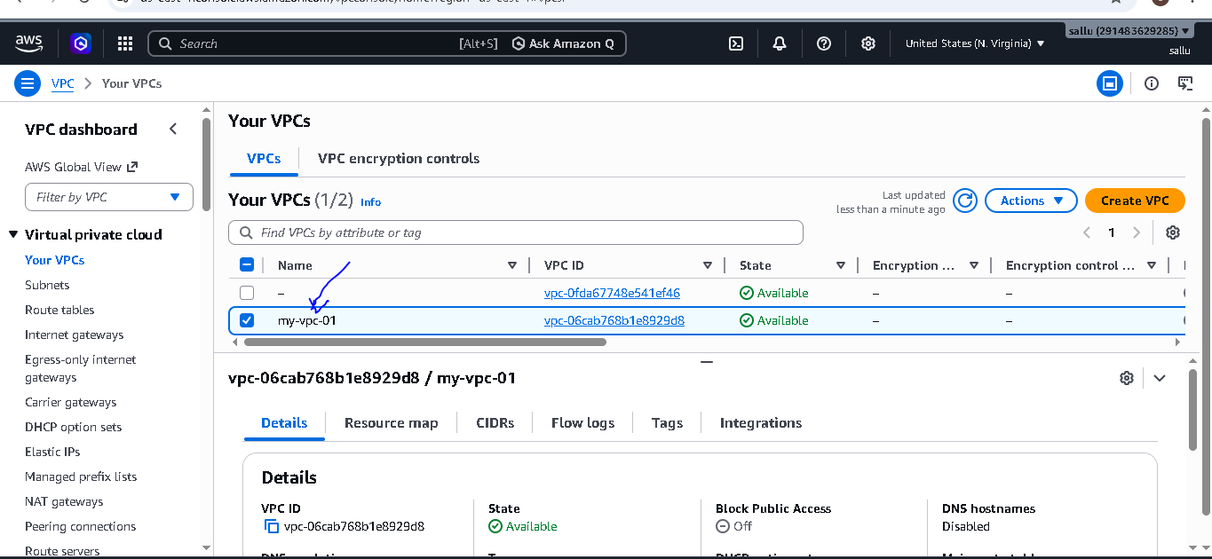

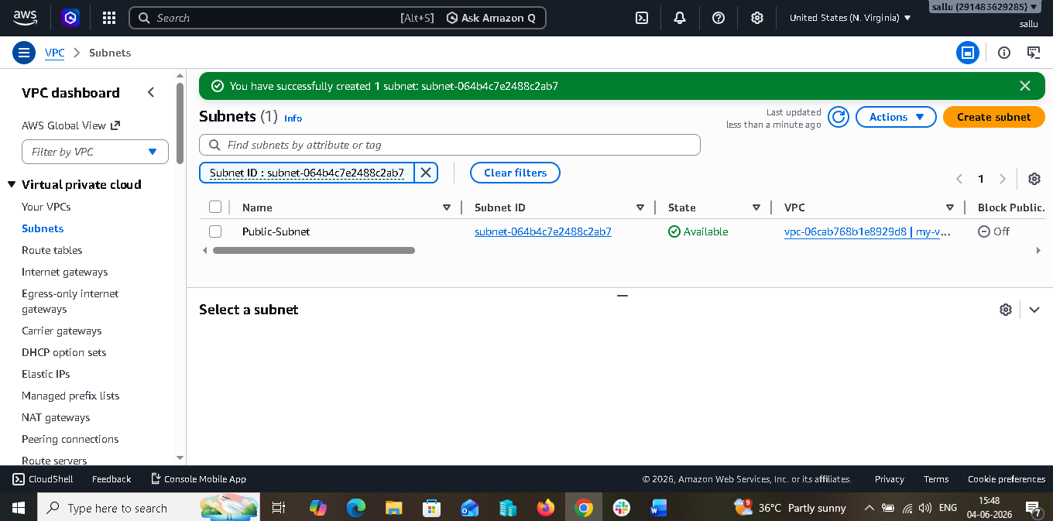

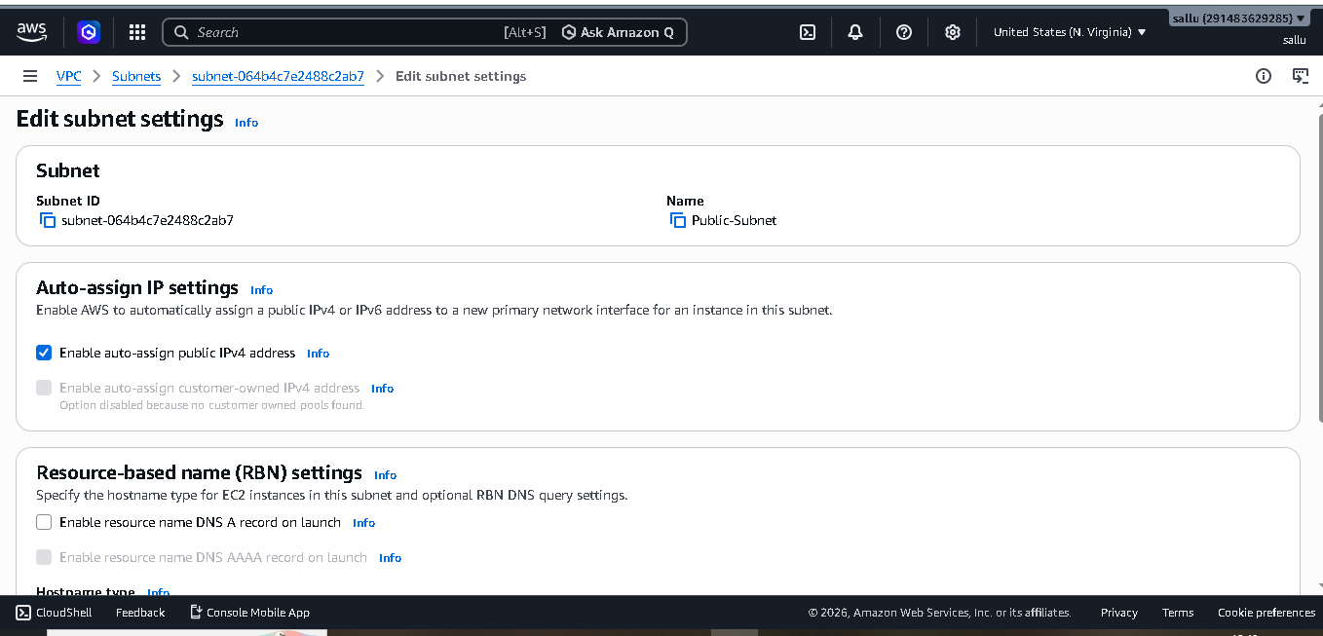



2. Enable VPC peering for cross-region:-

- ## Objective

- The objective of this task was to establish private communication between two VPCs located in different AWS regions using VPC Peering. This allows resources in both VPCs to communicate securely using private IP addresses without traversing the public internet.

- ## Step 1: Creation of VPCs in Different Regions

- Initially, two separate VPCs were created in different AWS regions. VPC-A was created in the N. Virginia (us-east-1) region with the CIDR block 10.0.0.0/16, while VPC-B was created in the Oregon (us-west-2) region with the CIDR block 20.0.0.0/16. Each VPC contained a subnet and an EC2 instance for connectivity testing.

- ## Step 2: Establishing the VPC Peering Connection

- After creating both VPCs, a VPC Peering Connection was initiated from VPC-A. During the configuration, VPC-A was selected as the requester VPC and VPC-B as the accepter VPC in another AWS region. Once the peering request was created, its status changed to Pending Acceptance.

- ## Step 3: Accepting the Peering Request

- The AWS console was switched to the second region where VPC-B resided. The pending peering request was located under the Peering Connections section and accepted. Upon acceptance, the peering connection status changed from Pending Acceptance to Active, indicating that the connection between the two VPCs had been successfully established.

- ## Step 4: Updating Route Tables

- Although the peering connection was active, communication between the VPCs was not possible until the route tables were updated. In VPC-A, a route was added directing traffic destined for the CIDR block of VPC-B through the peering connection. Similarly, in VPC-B, a route was added directing traffic destined for the CIDR block of VPC-A through the same peering connection. These routes enabled network traffic to flow between both VPCs.

- ## Step 5: Configuring Security Groups

- To permit communication between resources in both VPCs, the security groups attached to the EC2 instances were modified. ICMP traffic was allowed from the CIDR block of the remote VPC, enabling ping requests and connectivity testing between the instances.

- ## Step 6: Verifying Connectivity

- Finally, connectivity was verified by connecting to the EC2 instances and performing ping tests using their private IP addresses. Successful responses confirmed that traffic was flowing through the VPC Peering Connection and that cross-region communication had been successfully established.

- ## Outcome

- The task was completed successfully by creating a Cross-Region VPC Peering Connection between two VPCs located in different AWS regions. Route tables and security groups were configured appropriately, allowing EC2 instances in both VPCs to communicate securely using private IP addresses. This implementation provides a simple and efficient solution for private connectivity across AWS regions.

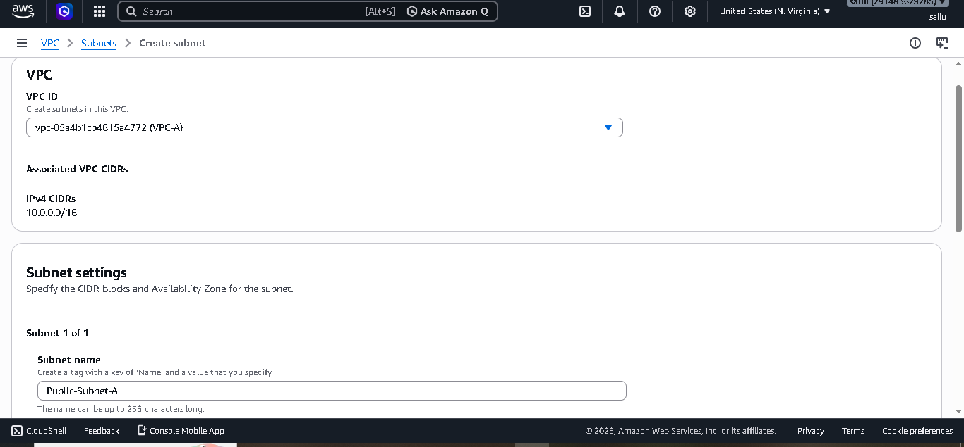

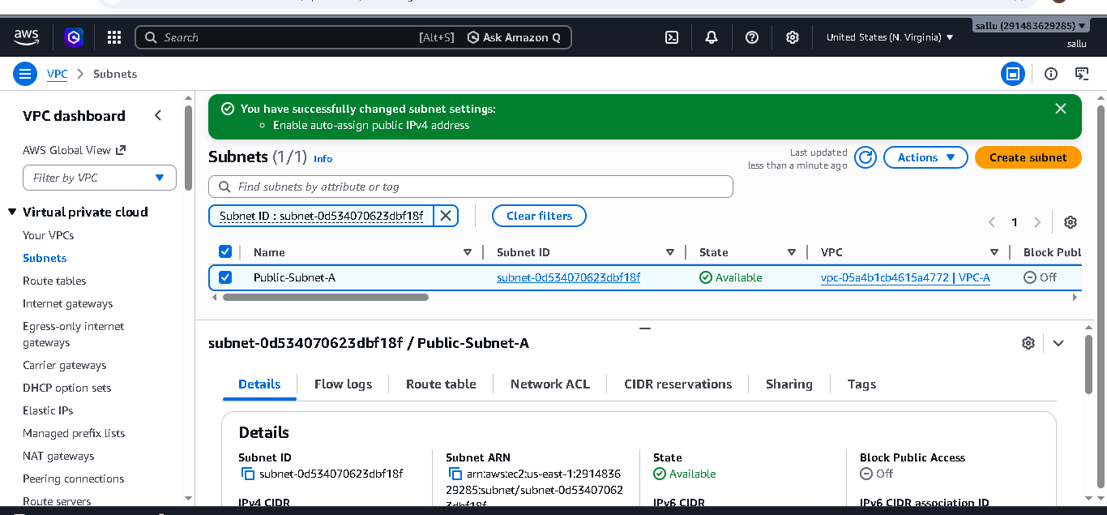

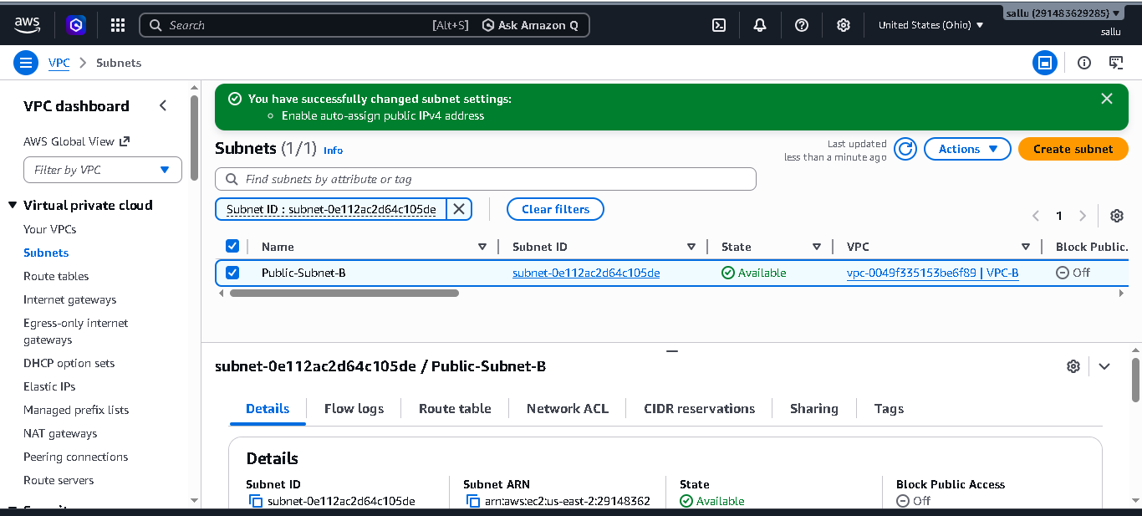

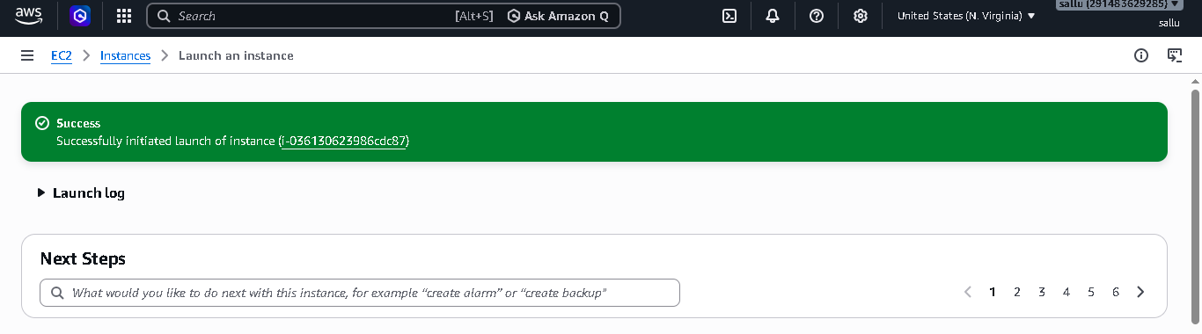
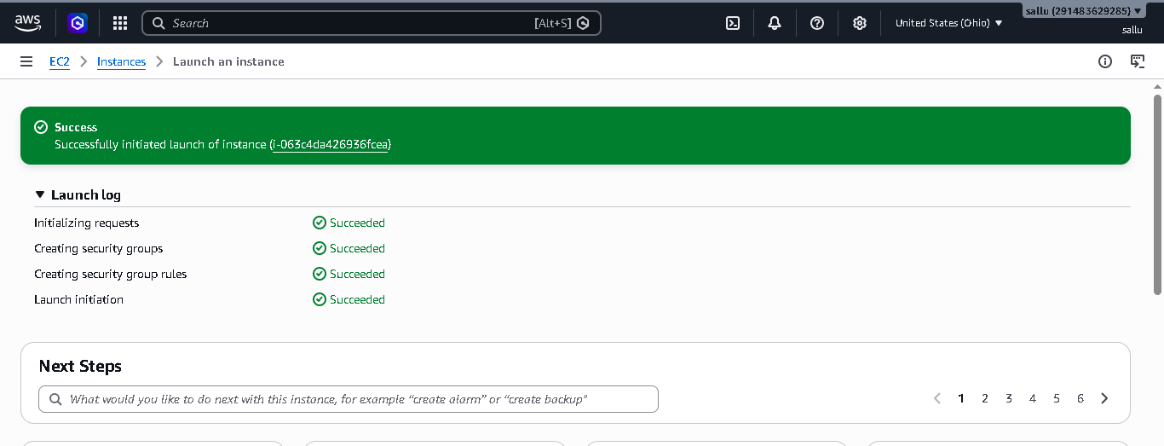
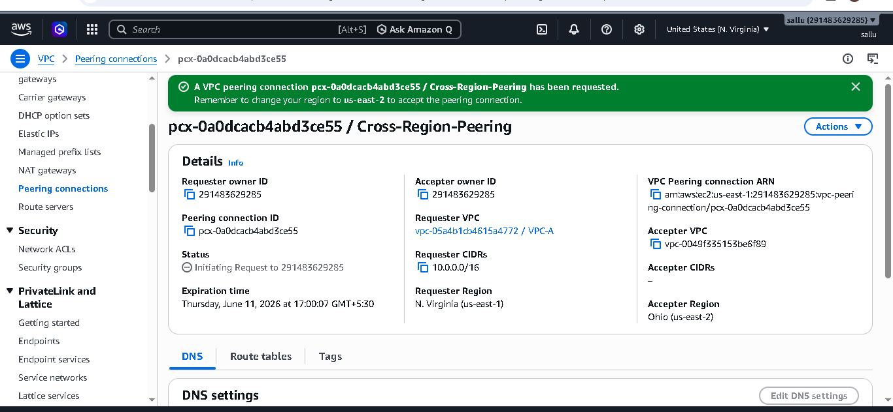

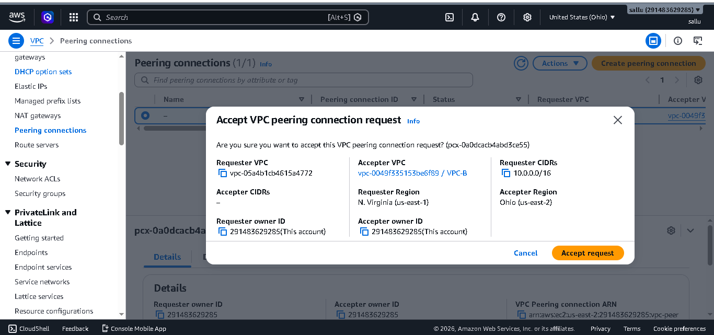

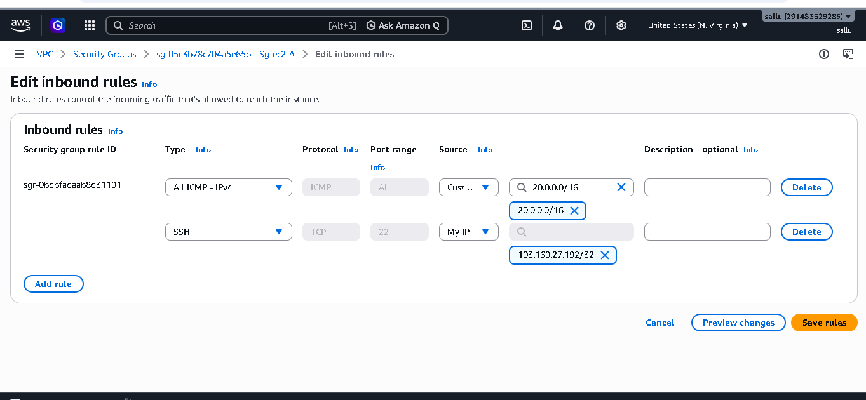

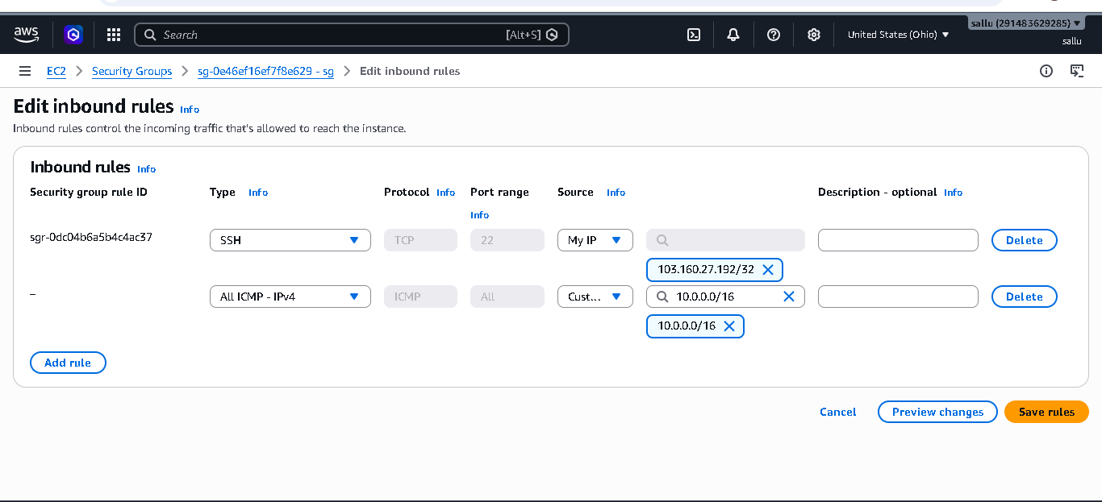

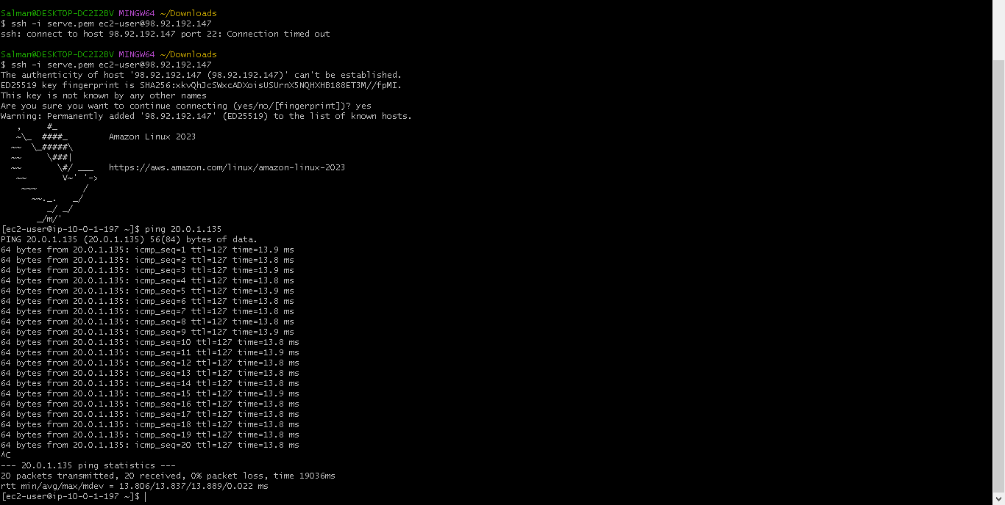

3. Enable VPC peering for cross-account (you can collaborate with your friend to do this task):-

- ## Objective:-

- The objective of this task was to establish secure private communication between two Virtual Private Clouds (VPCs) located in different AWS accounts using VPC Peering. This configuration enables resources in separate AWS accounts to communicate using private IP addresses without traversing the public internet.

- ## Step 1: Creation of VPCs in Separate AWS Accounts

- The first step involved creating two VPCs in separate AWS accounts. VPC-A was created in Account-1 with the CIDR block 10.0.0.0/16, while VPC-B was created in Account-2 with the CIDR block 20.0.0.0/16. Each VPC contained a subnet and an EC2 instance to facilitate connectivity testing after the peering connection was established.

- ## Step 2: Initiating the Cross-Account Peering Request

- After both VPCs were created, a VPC Peering Connection request was initiated from Account-1. During the configuration process, VPC-A was selected as the requester VPC. The AWS Account ID of Account-2 was provided, and VPC-B was selected as the accepter VPC. Once the request was submitted, the peering connection entered the Pending Acceptance state.

- ## Step 3: Accepting the Peering Request

- The owner of Account-2 logged into the AWS Management Console and navigated to the Peering Connections section. The pending peering request was reviewed and accepted. After acceptance, the status of the peering connection changed to Active, confirming that a connection had been successfully established between the two AWS accounts.

- ## Step 4: Updating Route Tables

- To enable network traffic between the two VPCs, route tables were updated in both accounts. In Account-1, a route was added directing traffic destined for the CIDR block of VPC-B through the peering connection. Similarly, in Account-2, a route was added directing traffic destined for the CIDR block of VPC-A through the same peering connection. These routing entries ensured that traffic could flow between both networks.

- ## Step 5: Configuring Security Groups

- Security groups associated with the EC2 instances were modified to allow communication between the VPCs. Appropriate inbound rules were configured to permit ICMP traffic from the CIDR range of the remote VPC. This enabled connectivity testing using ping requests and verified network communication between the resources.

- ## Step 6: Connectivity Verification

- Once the routing and security configurations were completed, connectivity tests were performed. EC2 instances in both VPCs were accessed, and ping commands were executed using private IP addresses. Successful responses confirmed that the cross-account VPC peering connection was functioning correctly and that private communication had been established.

- ## Outcome

- The Cross-Account VPC Peering configuration was successfully implemented between two AWS accounts. By establishing a peering connection, updating route tables, and configuring security groups, resources in both VPCs were able to communicate securely using private IP addresses. This solution provides a simple and efficient method for enabling private connectivity between workloads hosted in separate AWS accounts while maintaining network isolation and security.

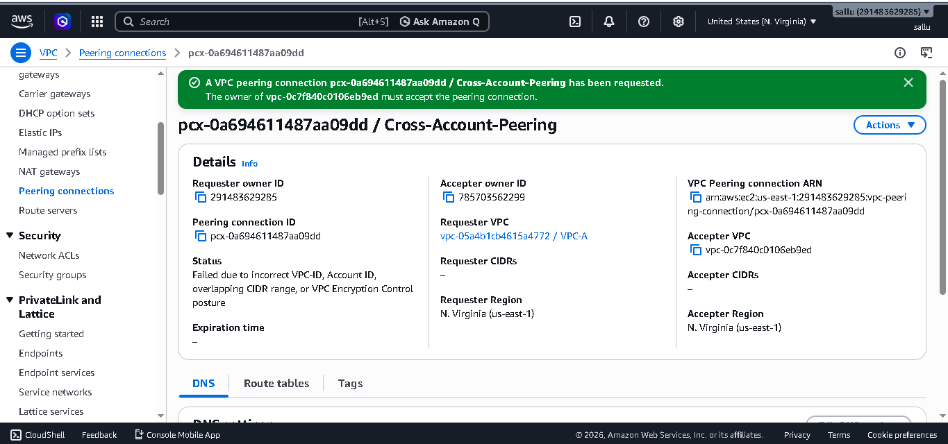

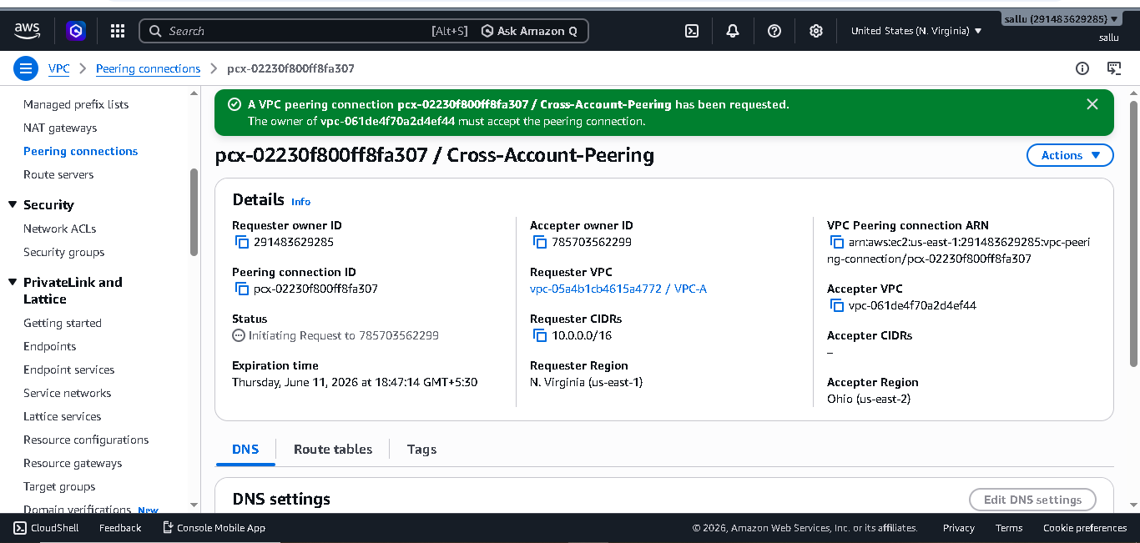

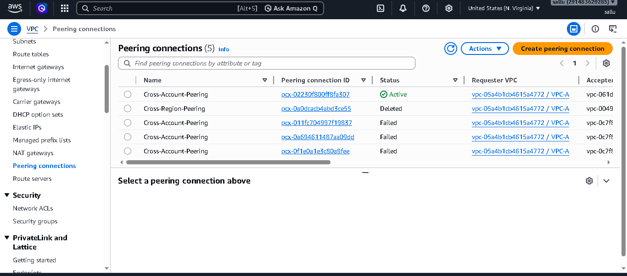

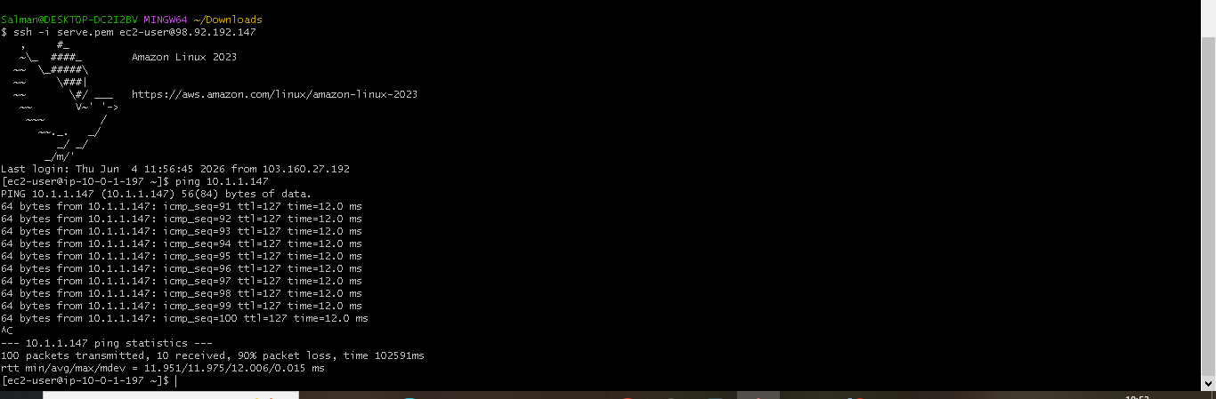

4. Set up a VPC Transit Gateway:-

- ## Objective

- The objective of this task is to establish secure communication between two separate VPCs using AWS Transit Gateway. Transit Gateway acts as a centralized routing hub that enables communication between multiple VPCs without requiring individual VPC peering connections.

- ## Step 1: Creation of VPCs

- Initially, two Virtual Private Clouds (VPCs) were created.

- VPC-A with CIDR block 10.0.0.0/16
- VPC-B with CIDR block 10.1.0.0/16

- These VPCs represent two isolated networks that need to communicate with each other.

- ---

- ## Step 2: Creation of Subnets

- A subnet was created inside each VPC.

- Subnet-A (10.0.1.0/24) in VPC-A
- Subnet-B (10.1.1.0/24) in VPC-B

- These subnets provide network segments where EC2 instances can be launched.

- ---

- ## Step 3: Internet Gateway Configuration

- Internet Gateways were created and attached to both VPCs. Route tables were updated with a default route (0.0.0.0/0) pointing to the Internet Gateway.

- This configuration enabled internet access and allowed SSH connectivity to the EC2 instances.

- ---

- ## Step 4: Security Group Creation

- Security Groups were created for both EC2 instances.

- The following inbound rules were configured:

- SSH (Port 22) for remote administration.
- ICMP (Ping) for connectivity testing between VPCs.
- Additional SSH access from the opposite VPC CIDR range for private communication.

- These rules ensured secure communication between the instances.

- ---

- ## Step 5: Launching EC2 Instances

- Two Amazon Linux EC2 instances were launched.

- ### EC2-A

- VPC: VPC-A
- Subnet: Subnet-A
- Security Group: SG-A
- Public IP: Enabled

- ### EC2-B

- VPC: VPC-B
- Subnet: Subnet-B
- Security Group: SG-B
- Public IP: Enabled

- The instances served as endpoints for validating Transit Gateway connectivity.

- ---

- ## Step 6: Transit Gateway Creation

- An AWS Transit Gateway named "My-TGW" was created.

- The Transit Gateway acts as a centralized router that manages traffic flow between multiple VPCs and simplifies network architecture.

- ---

- ## Step 7: VPC Attachments

- Both VPCs were attached to the Transit Gateway.

- ### Attachment 1

- Transit Gateway: My-TGW
- VPC: VPC-A
- Attachment Subnet: Subnet-A

- ### Attachment 2

- Transit Gateway: My-TGW
- VPC: VPC-B
- Attachment Subnet: Subnet-B

- These attachments established connectivity between each VPC and the Transit Gateway.

- ---

- ## Step 8: Route Table Configuration

- The route tables associated with each VPC were modified.

- ### VPC-A Route Table

- Added route:

- Destination: 10.1.0.0/16
- Target: Transit Gateway

- ### VPC-B Route Table

- Added route:

- Destination: 10.0.0.0/16
- Target: Transit Gateway

- These routes directed inter-VPC traffic through the Transit Gateway.

- ---

- ## Step 9: Transit Gateway Route Verification

- The Transit Gateway route table was verified to ensure propagation of both VPC CIDR blocks.

- The following routes were present:

- 10.0.0.0/16 → VPC-A Attachment
- 10.1.0.0/16 → VPC-B Attachment

- This confirmed that the Transit Gateway was aware of both VPC networks.

- ---

- ## Step 10: Connectivity Testing

- Connectivity was tested between the EC2 instances using private IP addresses.

- ### Ping Test

- From EC2-A:

- ping 10.1.1.x

- From EC2-B:

- ping 10.0.1.x

- Successful responses confirmed network connectivity through the Transit Gateway.

- ### SSH Test

- From EC2-A:

- ssh [ec2-user@10.1.1.x](mailto:ec2-user@10.1.1.x)

- From EC2-B:

- ssh [ec2-user@10.0.1.x](mailto:ec2-user@10.0.1.x)

- Successful SSH login confirmed secure communication between the VPCs using private networking.

- ---

- ## Outcome

- The AWS Transit Gateway was successfully configured to connect two independent VPCs. Both EC2 instances were able to communicate using private IP addresses through the Transit Gateway. This centralized networking approach simplifies management, improves scalability, and eliminates the complexity of maintaining multiple VPC peering connections.

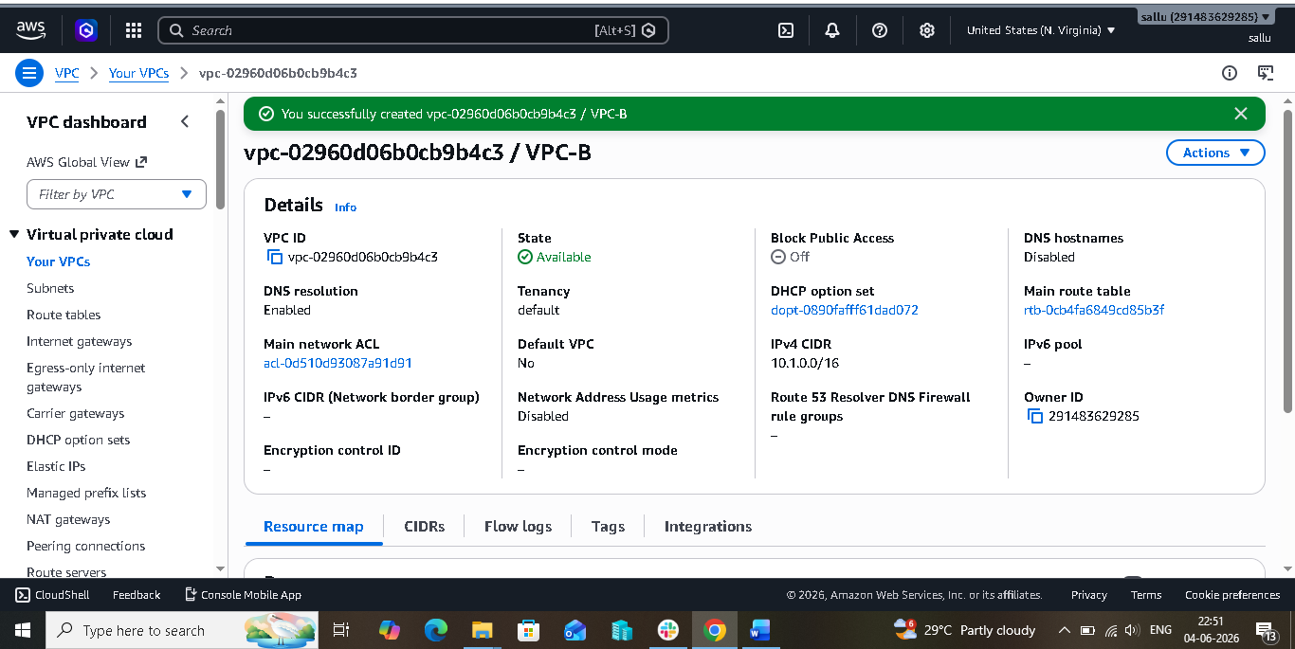

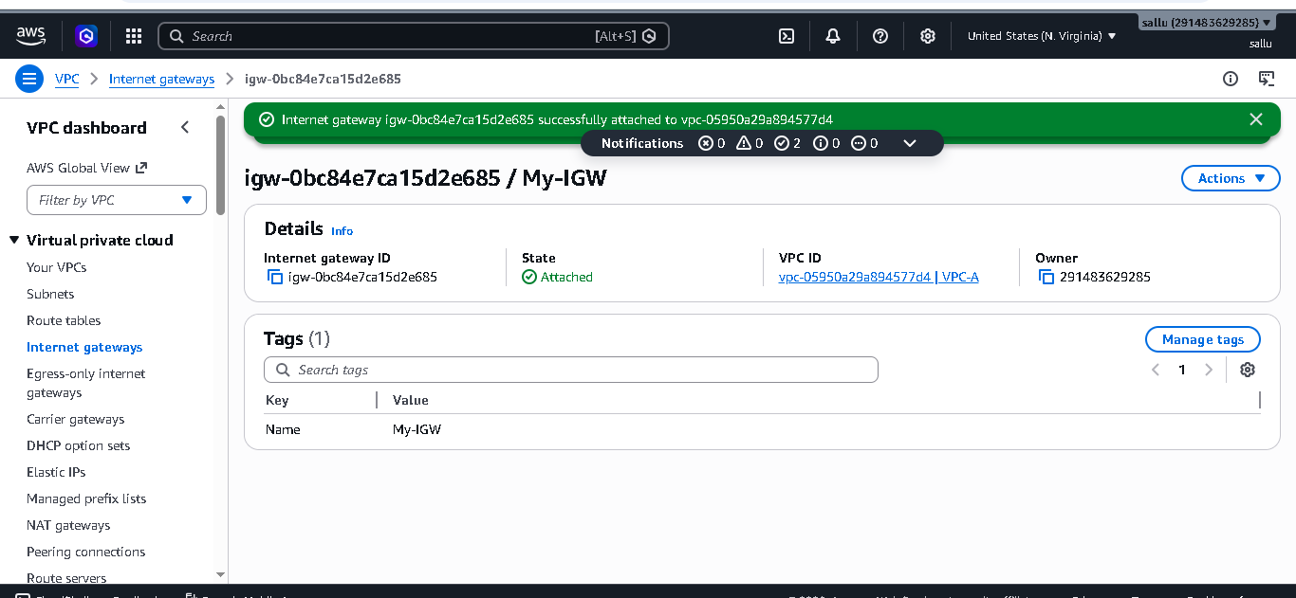

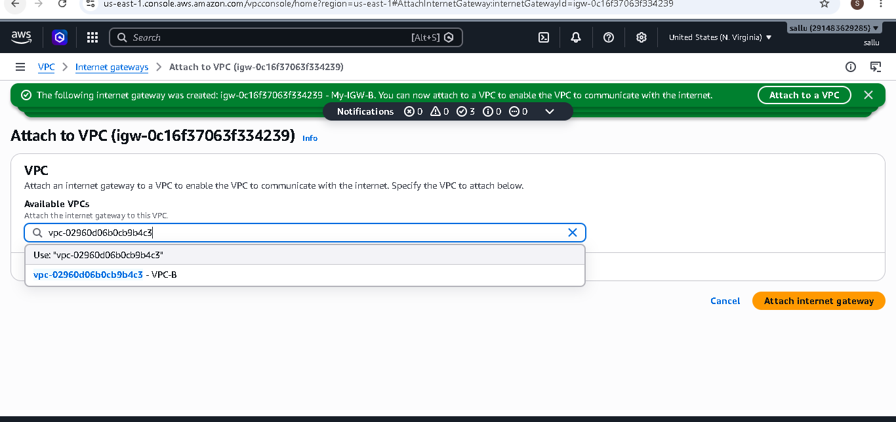

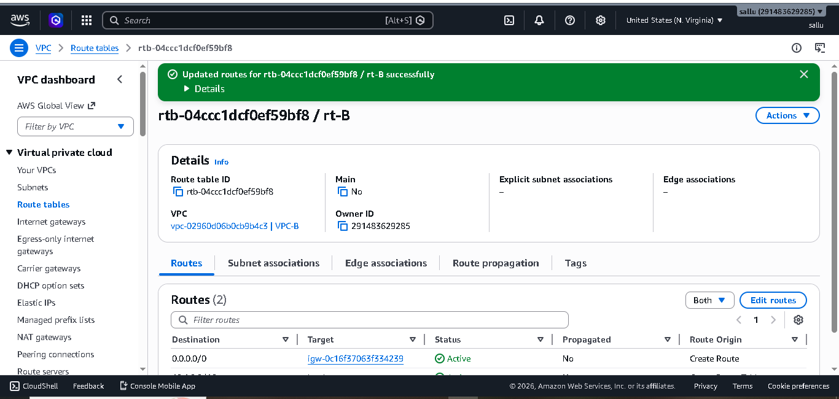

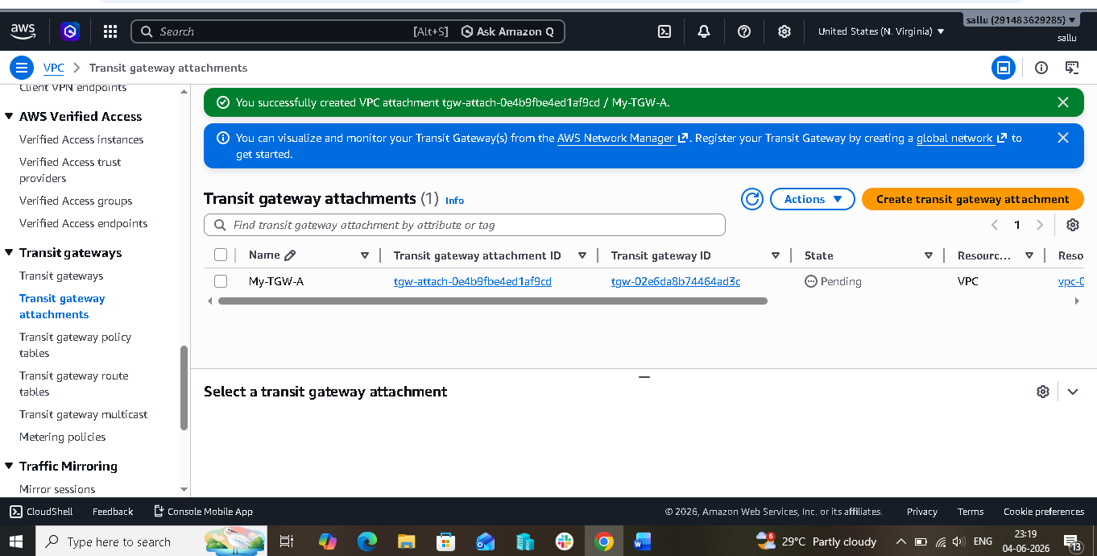
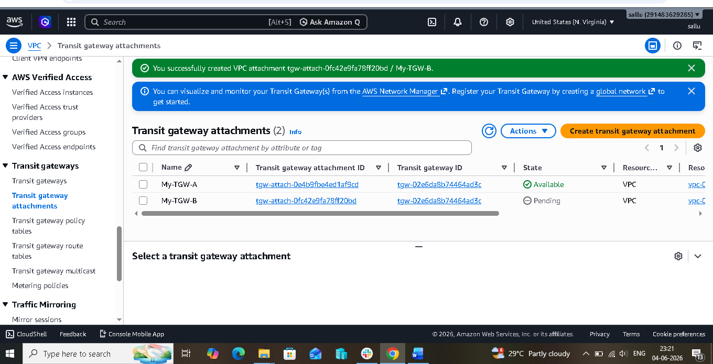

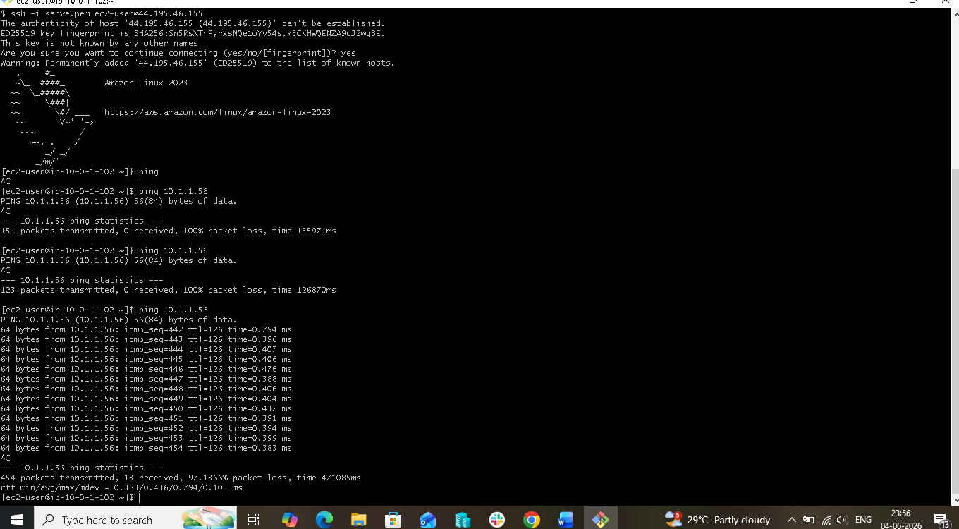

5. Set up a VPC Endpoint:-

- ## Objective

- The objective of this task was to establish private connectivity between an Amazon EC2 instance and Amazon S3 using a VPC Endpoint. This configuration allows AWS resources within a VPC to communicate with AWS services without requiring an Internet Gateway, NAT Gateway, VPN connection, or public internet access.

- ## Step 1: Creation of VPC

- A Virtual Private Cloud (VPC) named **Endpoint-VPC** was created with the CIDR block **10.0.0.0/16**. The VPC served as an isolated networking environment for hosting AWS resources.

- The VPC provided complete control over IP addressing, routing, and network security.

- ---

- ## Step 2: Creation of Private Subnet

- A private subnet named **Private-Subnet** was created within the VPC using the CIDR block **10.0.1.0/24**.

- The subnet was designed to host resources that do not require direct internet access, thereby enhancing security by keeping workloads isolated from public networks.

- ---

- ## Step 3: Route Table Configuration

- A route table named **Private-RT** was created and associated with the private subnet.

- This route table controlled how traffic originating from the subnet would be routed within the VPC and to AWS services through the VPC Endpoint.

- ---

- ## Step 4: Security Group Creation

- A Security Group named **Endpoint-SG** was created to secure the EC2 instance.

- Inbound rules were configured to allow SSH access for administration purposes. Security Groups act as virtual firewalls that control inbound and outbound traffic to AWS resources.

- ---

- ## Step 5: Launching EC2 Instance

- An Amazon Linux EC2 instance named **Endpoint-EC2** was launched within the private subnet.

- The instance was configured without a public IP address, ensuring that it remained inaccessible directly from the internet. This setup demonstrated how private resources can securely access AWS services using a VPC Endpoint.

- ---

- ## Step 6: Creation of Amazon S3 Bucket

- An Amazon S3 bucket was created to store sample files used for testing connectivity.

- A test file was uploaded to the bucket to verify that the EC2 instance could successfully access S3 resources through the VPC Endpoint.

- ---

- ## Step 7: Creation of VPC Endpoint

- A Gateway VPC Endpoint for Amazon S3 was created within the VPC.

- During the configuration process:

- The AWS service category was selected.
- Amazon S3 service was chosen.
- The VPC Endpoint was associated with the VPC.
- The Private Route Table was selected.
- Full access policy was applied.

- The VPC Endpoint established a private connection between the VPC and Amazon S3.

- ---

- ## Step 8: Route Table Update

- After the VPC Endpoint was created, AWS automatically updated the associated route table.

- A new route containing an AWS-managed prefix list was added and directed traffic destined for Amazon S3 to the VPC Endpoint.

- This ensured that requests to Amazon S3 would travel through the AWS private network rather than the public internet.

- ---

- ## Step 9: IAM Role Configuration

- An IAM role with Amazon S3 access permissions was created and attached to the EC2 instance.

- The role allowed the EC2 instance to securely access S3 resources without requiring access keys or credentials stored on the server.

- ---

- ## Step 10: Connectivity Verification

- The EC2 instance was used to verify connectivity with Amazon S3.

- AWS CLI commands were executed to:

- List available S3 buckets.
- Access the contents of the test bucket.
- Verify successful communication between EC2 and S3.

- The successful execution of these commands confirmed that the VPC Endpoint was functioning correctly.

- ---

- ## Working Principle

- Without a VPC Endpoint, communication between EC2 and S3 would typically require internet access through an Internet Gateway or NAT Gateway.

- With a VPC Endpoint, traffic follows the path:

- EC2 Instance → VPC Endpoint → Amazon S3

- All communication remains within the AWS private backbone network, improving security and reducing exposure to public networks.

- ---

- ## Outcome

- The VPC Endpoint was successfully configured to provide private connectivity between the EC2 instance and Amazon S3. The EC2 instance was able to access S3 resources securely without using the internet. This implementation improved security, reduced dependency on external networking components, and demonstrated the use of AWS private networking services for accessing AWS resources.

